1 Analysis
1.1 Research of the Problem
The current system:
- There are websites which allow a user to track satellites on a 2D map, or simply track a satellites position, however these websites are outdated, and aren’t that user friendly. These websites are also slow and don’t perform that well. There are also systems which allow users to track aeroplanes in the sky.
- The users of this system are likely to be satellite enthusiasts or people looking to track objects in orbit such as stargazers. Some users my want to track recently launched objects, and any objects falling back to earth.
- The skill level of the users will likely vary, as there may some users who are tech savvy such as students etc. however there is also likely to be users that may need a simpler UI in order to utilise the program fully.
What users want the new system to do:
- Potential users need to be asked about what features they would like.
1.1.2 Research into Satellite tracking
Methods of storing satellite data:
There are different possible ways of storing satellite data, for example, a satellite’s inclination, height, period etc. can be generated and put into a database. However, on further research the TLE format is the simplest and most effective method of storing satellite data for orbital predictions, there is also a large public. The best summary of this information about the TLE format and how it can be used for orbital predictions can be found in this Wikipedia article, more detailed information can be found here and even more here. The format of the TLE can be found here. One important detail to note is that TLEs are not perfectly accurate. There are two points here:
- They can only be as accurate as the data source, which in most cases is almost always NORAD.
- To quote directly from Revisiting Spacetrack Report #3 Appendix B:
“The maximum accuracy for a TLE is limited by the number of decimal places in each field. In general, TLE data is accurate to about a kilometre or so at epoch and it quickly degrades.”
So, in summary, the use of TLEs is ideal.
Methods of predicting satellites using given data:
Could use parametric equations to create a 3d circle with a specified radius, this can be found from the orbital height, however a problem arises in order to show the actual position of this orbit. A much easier method of plotting the orbits is using the python module Skyfield. The best thing about this is that it can take TLE input and uses a prediction model to return points of a given satellite’s orbit at given times.
1.2 Platform:
- I’m choosing to develop the system as an application, because this allows for greater graphical performance, as well as being easier for me to make.
- I’m going to utilise a client-server system where the application connects to a server which has an updated list of satellite information, the application plots this information. This is so that for all users of the system, the information is synced. This also allows the ability to change the source of data centrally.
- A web-based version could be possible as python for web backend is becoming more popular; however, this could bring issues with performance and may create more issues.
1.3 Problem:
- Currently, a person may not know what objects are in space and, may not know what objects are passing overhead. Also, it may be helpful for organisations which want to track an object or satellite as it may interfere with their own satellite(s), e.g. satellite company tracking other satellites to see if they might collide. However, the main purpose is for those who want to track objects in orbit, this may include stargazers, as they may wish to know if the object, that they are looking at is a satellite. T
1.4 Objectives:
Specific, Measurable, Attainable, Relevant, and Time-Bound.
- The system will allow a user to select satellites they want to be displayed.
  - S – Yes
  - M – Yes, through screenshots.
  - A – yes, this should be possible
  - R – yes, this is essential for the system
  - T – This should be achieved in the time given
- The system will display the orbits around a spherical earth and be able to pan around to view the orbits.
  - S – Yes
  - M – Yes, through screenshots
  - A – Maybe, this should be possible, however it is possible that there could be issues with displaying a 3D sphere, as well as plotting an orbit.
  - R – Yes, this makes it easy for the user to view where the satellite flies over
  - T – Maybe, this is possible in the time given however, problems may delay it.
- The system will retrieve the relevant information regarding the selected satellite from a database.
  - S – yes,
  - M – yes, if the information can be shown in the application
  - A – yes, this should be possible
  - R – yes, this allows use with other sources of data, for example if an organisation wishes to use this program with their own
  - T – Yes, this should be achieved in the given time.

1.5 Solution
- The solution involves designing an object tracking system, which offers the ability for the user to view objects overhead in real time – as well as having the functionality to track objects in orbit around earth. The solution should be simple, easy to use, and should turn out like flightradar24 but for objects in space.
1.5.1 Potential solutions:
Suggested solutions | Positives | Negatives
Python, tkinter and matplotlib application | I have some experience with python and tkinter already. Python will allow me to easily calculate orbits and retrieve information from a database. | Tkinter often looks rudimentary.  The program will only be available offline. Matplotlib unlikely to be powerful enough for what I need.
Using Python and either Mayavi or matplotlib to create a web application. | The program will be available online. Would be able to display the application in a user-friendly way. | Given the current complexity of the project already, attempting to turn it into a web app will add too much complexity.
Python, Mayavi, and PyQt5 application. The Mayavi library will be used to calculate orbits and display them on a 3D plot using a module called mlab. This plot can be embedded into a GUI using PyQt5, to make the program easy to use. | Mlab (part of Mayavi) is much more effective than matplotlib at displaying objects in 3d. Mayavi gives an easy solution to calculating the various points of an orbit which can then be used to display it. PyQt5 allows custom widgets to be embedded into a GUI and uses native tools when building the GUI | Will be complex.  Will require me to learn how to use the module along with many other modules it is dependent on. Will also have to learn how to use PyQt5.

1.5.2 Chosen solution:
Python, Mayavi and PyQt5 application. This is because it will be the easiest way to make the application, given it is already quite complex. This solution will utilise python to retrieve satellite information from a database on a separate server and update the information in the database if it is out of date. The program will then use said information to calculate the satellites approximate location using its period of orbit. All this data will be displayed by the GUI. The GUI will display the orbit, around the earth, and any relevant information to that satellite. The satellite information is to be taken from a public data source (https://celestrak.com/) and put into the database. This database will sit on a central server which the application connects to.
1.6 Modelling of the Problem
1.6.1 Initial Data Flow Diagram:
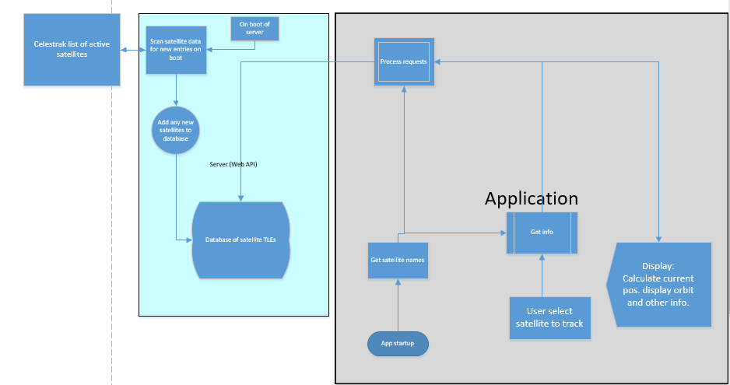
1.7 Prospective Users
1.7.1 Questionnaire:
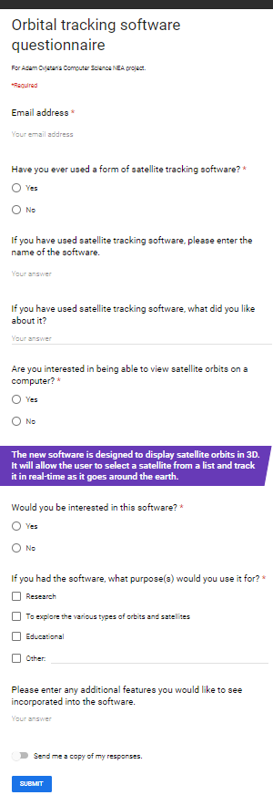

1.7.2 Interview
1.8 System Modelling and Planning:
Hierarchy chart
Managing access to the database, and request processing.
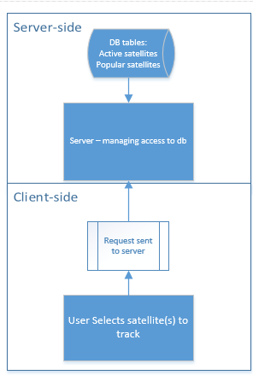

2 Design
2.1 Overall System design
Inputs | Processes | Storage | Outputs
User’s choice of satellite to track. | Select satellite  Get satellite data  Calculate points to plot | Database tables:  1000 active satellites  Popular satellites  Different constellations | Plot satellite(s) and their current location
Persistent server design
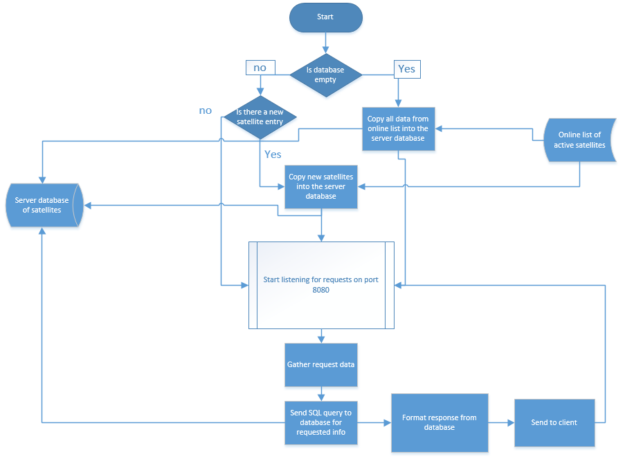
Application Design Overview
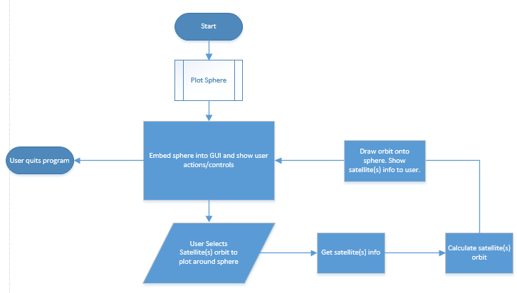
Processing data sent from the server
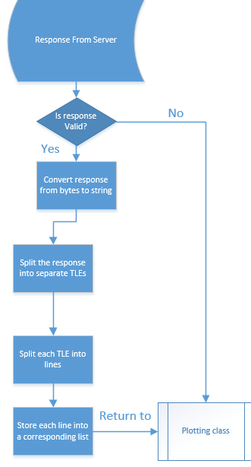
2.3 Description of data structures
2.3.1 How satellite information is being stored:
Satellites are to be stored in the database using the Two-Line Element set (TLE).
What is a TLE?
- This is a way of storing orbital data so that its orbital path can be predicted to some accuracy.
- Example:
ISS (ZARYA)
1 25544U 98067A 08264.51782528 -.00002182 00000-0 -11606-4 0 2927
2 25544 51.6416 247.4627 0006703 130.5360 325.0288 15.72125391563537
Data can be extracted by splitting each line into lists.
2.3.2 Where satellite information is being stored:
The satellite information is held in a public archive of frequently updated TLEs found here[https://celestrak.com/]. This information is then downloaded into a database on a server, which the application can access.

2.4 Data Dictionary
2.4 Database Design
2.5 SQL statements
2.5.1 Creation of Database Tables
CREATE table mydatabase.tles (id INT AUTO_INCREMENT PRIMARY KEY, name VARCHAR(255), line1 VARCHAR(255), line2 VARCHAR(255));
2.5.2 Adding TLEs to database table
After getting requested TLE from https://www.celestrak.com/, insert each line seperately into the database.
"INSERT INTO tles (name, line1, line2) VALUES (satName, line1, line2);"
TLE variables
Columns in database

2.6 Data Processing
2.6 Class Design
2.5 Description of algorithms
2.7 Interface Design
https://app.moqups.com/j9aAHywMbL/view
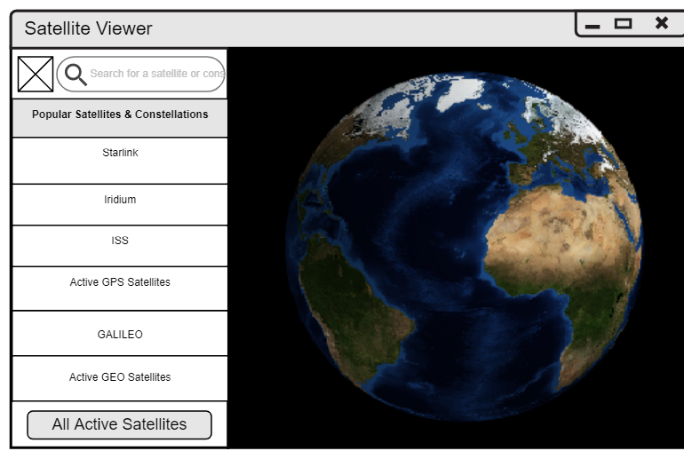
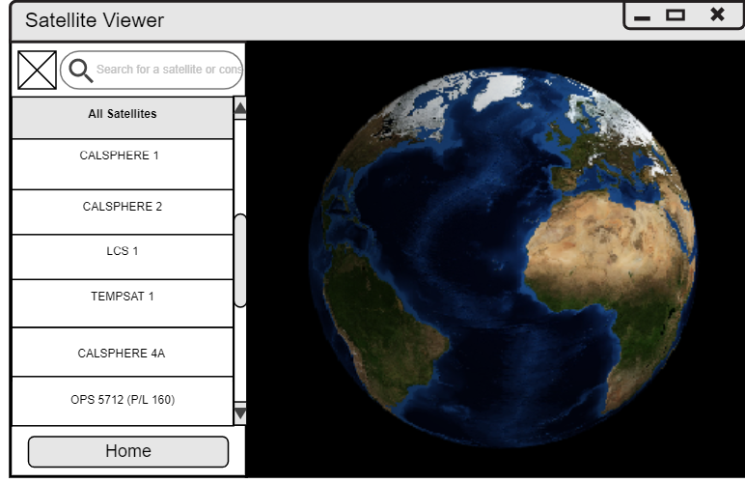
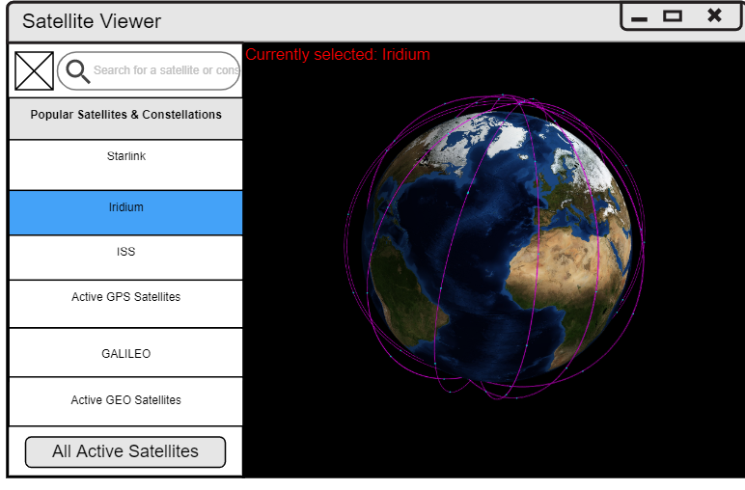
2.8 Integrity of Data
Technical solution

Testing

Evaluation

Notes
Managing concurrent access to database (server):
Client sends a request to the server. Request logged with timestamp and added to a queue. When server is ready it removes a request from the queue. The server then queries the database using the request selected.
Updating the database with new satellites:
- Needs to be fast, so it cannot redownload all the active satellites.
The system

Skyfield important points taken directly from Skyfield Earth Satellites:
- The accuracy of the satellite positions is not perfect.
To quote directly from Revisiting Spacetrack Report #3 Appendix B:
“The maximum accuracy for a TLE is limited by the number of decimal places in each field. In general, TLE data is accurate to about a kilometre or so at epoch and it quickly degrades.”
- Satellite elements go rapidly out of date. You will want to pay attention to the “epoch” — the date on which an element set is most accurate — of every TLE element set you use. Elements are only useful for a week or two on either side of the epoch date, and for dates outside of that range you will want to download a fresh set of elements.
- Expect a satellite’s orbit to constantly change as the SGP4 propagation routine models' effects like atmospheric drag and the Moon’s gravity. In particular, the true anomaly parameter can swing wildly for satellites with nearly circular orbits, because the reference point from which true anomaly is measured — the satellite’s perigee — can be moved by even slight perturbations to the orbit.

Issues
If a satellite’s orbit is changed, it will not be updated in the program yet
When the program loads up, a GUI is shown. On that GUI is the first MayAvi scene - with just the earth in 3D.
Upon selecting or searching for a satellite(s) - its position(s) are shown, and the trajectories are plotted.
However, after this, the Widget does not seem to update when another satellite is selected.
I suspect this is down to the widget not being refreshed properly, but I can't seem to find a fix.

